Dear Aspirer,
Project report is an inherent component of your Industry Project. We are enclosing a reference table of content for the project report. Depending on the Industry project, you may choose to include or exclude or rename sections from the Table of Content mentioned below. You can also showcase your creativity to present the report. The key objective of this report is for you to comprehensively document the project work done.
Industry Project Title | PERSONAL FINANCE TRACKER
Name of the Company | TCS iON
Name of the Institute | MpOnline

Start Date | End Date | Total Effort (hrs.) | Project Environment | Tools used
Oct - 2025 | Nov - 2025 | 90 | C++ console-based application | C++17, Visual Studio Code

TABLE OF CONTENT
- Acknowledgements
- Abstract
- Introduction
- Objective and Scope
- Problem Statement
- Existing Approaches
- Approach / Methodology - Tools and Technologies used
- Workflow
- Assumptions
- Implementation - Data collection, Processing Steps, Diagrams - Charts, Table
- Solution Design
- Challenges & Opportunities
- Reflections on the project
- Recommendations
- Conclusion
- Output
- Link to code and executable file
- Research questions and responses
- References

ACKNOWLEDGEMENTS

I would like to express my sincere gratitude to TCS iON PSP for providing me with the opportunity to work on this comprehensive and enriching project. The Industry Project has played a pivotal role in enhancing my technical skills and offering valuable exposure to real-world software development challenges.
I am especially thankful to Atul Kumar Gupta, whose invaluable guidance, constant support, and expert insights have been crucial throughout the entire project lifecycle. His patience in explaining complex concepts, providing constructive feedback, and sharing industry best practices has significantly enriched my learning experience and contributed to the successful completion of this project.
I would also like to extend my heartfelt thanks to Sumanpreet Hora and Ifra Shareef for their continuous support and encouragement throughout this journey. Their inputs, mentorship, and collaboration have been instrumental in shaping the outcome of this project.
The mentorship and resources provided by TCS iON PSP have not only enabled me to develop a robust Event Booking Management System but have also instilled in me the confidence to tackle future challenges in software development. I am truly grateful for the knowledge, experience, and professional growth I have gained through this opportunity.
DATE : 16/10/2025
PLACE:BHOPAL

ABSTRACT

The Personal Finance Tracker is a console-based application developed in C++ using Object-Oriented Programming (OOP) principles. It helps users manage their personal finances by recording, categorizing, and analyzing income and expenses. The system allows users to add transactions, generate monthly and overall reports, and store data permanently using file handling techniques.
The main goal of the project is to provide a simple, offline, and user-friendly way for individuals to monitor their financial activities without relying on internet-based tools. By applying OOP concepts such as encapsulation, inheritance, abstraction, and polymorphism, the project ensures modularity, scalability, and code reusability.
The application’s design includes three layers — a presentation layer (console interface), a business logic layer (core classes for transactions and reports), and a data layer (file management for data persistence). This structure makes the program organized, efficient, and easy to maintain.
Overall, the Personal Finance Tracker demonstrates how C++ and OOP can be effectively used to create practical software solutions for real-life problems. It not only helps users track their income and expenses but also serves as an educational project for learning structured programming, data handling, and software design.

TABLE OF CONTENT

PERSONAL FINANCE TRACKER 1
ACKNOWLEDGEMENTS 2
ABSTRACT 3
TABLE OF CONTENT 4
INTRODUCTION 6
OBJECTIVE AND SCOPE 7
1. OBJECTIVE 7
2. SCOPE 7
PROBLEM STATEMENT 9
EXISTING APPROACHES 10
APPROACH / METHODOLOGY 12
TOOLS AND TECHNOLOGIES USED 13
WORKFLOW 14
WORKFLOW SUMMARY DIAGRAM 16
ASSUMPTIONS 17
IMPLEMENTATION 18
1. DATA COLLECTION 18
2. PROCESSING STEPS 18
3. DIAGRAMS 19
4. TABLES AND DATA REPRESENTATION 19
SOLUTION DESIGN 20
1. PRESENTATION LAYER (CLI) 21
2. BUSINESS LOGIC LAYER 21
3. DATA LAYER (PERSISTENCE) 21
CHALLENGES & OPPORTUNITIES 22
1. CHALLENGES 22
2. OPPORTUNITIES 22
REFLECTIONS ON THE PROJECT 23
RECOMMENDATIONS 24
CONCLUSION 25
OUTPUT 26
LINK TO CODE AND EXECUTABLE FILE 27
RESEARCH QUESTIONS AND RESPONSES 28
REFERENCES 29

INTRODUCTION

In today’s digital world, handling money wisely is very important. Many people find it difficult to record their income and expenses, which causes poor financial planning and confusion about their money. To solve this problem, we created a Personal Finance Tracker project. It is an easy-to-use console application made in C++ using Object-Oriented Programming (OOP).
In today’s digital world, managing money wisely is very important. Many people find it difficult to keep proper records of their income and expenses, which can lead to poor financial planning and confusion about where their money goes.
To solve this problem, the Personal Finance Tracker was created. It is a simple console-based application written in C++ using Object-Oriented Programming (OOP) principles.
The main goal of this project is to help users easily record, organize, and analyze their financial activities. Users can add, edit, and view their income and expenses. The system also creates monthly and overall reports, helping users understand their spending habits and savings trends.
The project uses OOP concepts like abstraction, encapsulation, inheritance, and polymorphism to make the code more structured and maintainable. Classes such as Transaction, Income, Expense, Account, and ReportGenerator are used to organize the program logically.
File handling ensures that all data is saved even after the program is closed. The project follows software engineering principles like modular design, input validation, error handling, and usability. It was built using C++17 in Visual Studio Code, with diagrams created in PlantUML and documentation in Microsoft Word.

OBJECTIVE AND SCOPE

OBJECTIVE
The main goal of the Personal Finance Tracker is to create an efficient, user-friendly, and reliable tool to help individuals manage their personal finances using OOP in C++.
The system aims to:
- Record and categorize both income and expenses.
- Maintain and update account balances automatically.
- Generate monthly and total reports of financial activity.
- Save all data permanently in a file.
- Provide a simple console interface for easy use.
Using OOP concepts ensures the system is modular, scalable, and easy to maintain

2. SCOPE
The project focuses on local, offline financial management. It is designed for people who want to organize their income and expenses without using internet-based tools.
The system allows users to:
- Add, view, and analyze financial records.
- Calculate balances automatically.
- Create categorized reports for months or overall use.
- Store data safely in a local file (finance_data.txt).

PROBLEM STATEMENT

In today’s fast-paced, digital world, people often struggle to keep an organized record of their financial activities. Managing personal income and expenses using notebooks or spreadsheets can be tedious, full of errors, and time-consuming. Most individuals do not have an easy way to look at their spending habits or savings over time. This often results in poor financial decisions and ineffective budgeting.

Although many finance management tools are available, they have their downsides. Many require internet access, user registration, or paid subscriptions, which can be a barrier for those who prefe0r simple and offline options. Additionally, these applications often have complex interfaces that may not be friendly to beginners or those learning programming concepts related to financial tracking systems.

There is a clear need for a straightforward, efficient, offline personal finance management system that can help users:
- Record income and expenses with details like date, category, and description.
- Maintain an ongoing account balance that shows their financial health.
- Generate monthly and overall reports to examine trends and control spending.
- Keep transaction data even after the program is closed.
To fill this gap, the Personal Finance Tracker project has been developed using Object-Oriented Programming (OOP) principles in C++. This system not only addresses the challenge of manual financial tracking but also acts as a teaching tool for OOP concepts like abstraction, encapsulation, inheritance, and polymorphism.

By combining practical use with educational value, this project seeks to connect theoretical programming knowledge with real-world financial management challenges.

In today's financial technology landscape, many digital tools and applications help users manage their personal finances. Popular options like IN Simple word and other language

However, these existing approaches have several drawbacks compared to the educational and offline goals of this project:
Dependence on Internet Connectivity:
Most commercial applications need constant internet access to sync data across devices. This requirement can limit users who prefer an offline, secure, and self-contained solution.

Data Privacy Concerns:
Many online platforms store financial data on external servers or in the cloud, which can pose privacy and security risks. Users often have little control over how their data is used or shared.

Subscription or Licensing Fees:
Tools like YNAB and PocketGuard operate with a subscription model, which can be a financial burden for students and individuals seeking a free alternative.

Complexity of Use:
While these systems offer many features, many have complex interfaces and settings that may overwhelm new users or beginners learning programming basics.

Limited Educational Value:
Current tools work as closed systems; they do not reveal their underlying architecture or logic. This makes them unsuitable for learners who want to understand how financial tracking systems operate.

In contrast, the Personal Finance Tracker project emphasizes simplicity, transparency, and educational benefits. It provides an offline, open-source, and lightweight way of managing personal finances using pure C++ programming. By manually implementing core functions like transaction entry, file storage, and report generation, this project not only addresses the limitations of existing tools but also gives a valuable hands-on learning experience for software developers.

Overall, while current market applications excel in automation and convenience, the Personal Finance Tracker stands out as an educational, customizable, and privacy-focused solution. It shows how object-oriented programming principles can be effectively used to create real-world software systems.

APPROACH / METHODOLOGY

The Personal Finance Tracker project was created step by step using Object-Oriented Programming (OOP) principles and basic software engineering practices. The development process was divided into well-defined stages — including planning, design, implementation, and testing — to ensure the system operates efficiently and can be easily maintained or expanded later on.

1. Requirement Analysis
In this initial phase, we identified what the system needs to accomplish.
- It must allow users to record, categorize, and display both income and expense transactions.
- The application should be user-friendly, store data securely, and manage file operations effectively.

2. System Design and Architecture
After gathering requirements, we outlined the structure of the system.
- UML diagrams were used to illustrate the relationships between different classes and data components.
- A Class Diagram, created with PlantUML, showed the connections among the main classes: Transaction, Income, Expense, Account, and ReportGenerator.
- Each class was assigned a clear responsibility to maintain a modular, simple, and well-organized design.

3. Implementation
The program was implemented in C++17, utilizing OOP principles such as encapsulation, inheritance, and polymorphism.
- The Transaction class serves as the base class, defining the shared structure for all financial operations.
- The Income and Expense classes inherit from Transaction and modify the account balance through the apply() function.
- The Account class manages all transactions, updates balances, and handles data persistence by saving and loading information from files.
- The ReportGenerator class processes stored data to generate reports by month and category, helping users better understand their financial habits.

TOOLS AND TECHNOLOGIES USED

Category | Tool / Technology | Purpose / Description
Programming Language | C++17 | Main language used to build the system using object-oriented programming principles.
IDE / Editor | Visual Studio Code | Utilized for writing, editing, and debugging the program’s source code.
Compiler | GCC (GNU Compiler Collection) | Responsible for compiling and running the C++ programs
Diagram Tool | PlantUML | Employed to design class diagrams and represent relationships among system components
Documentation  Tool | Microsoft Word | Used to create and format the final project documentation.
Version Control | Git (Optional) | Provides version tracking and manages changes in the project’s source code.
Operating System | Windows 10 | Platform used for running, testing, and validating the application.

WORKFLOW

Here’s a rewritten version of your text, with the same meaning but expressed in different words and phrasing:

The workflow of the Personal Finance Tracker describes the sequence of actions the system performs—from user interaction to data handling and report generation. It illustrates how the different modules coordinate to deliver a seamless user experience while maintaining data accuracy and program efficiency.
This workflow is divided into six main stages, each representing a key function of the system:

1. Application Startup
When the program launches, it first checks whether the transaction file (finance_data.txt) exists.
- If the file is found, all previous transaction records are loaded into memory, and the current account balance is updated.
- If the file is not available, the system begins with a starting balance of Rs. 0.00, ready to log new financial entries.

2. User Interaction and Menu Options
After initialization, the system displays a main menu that allows users to perform different actions:
- Add Income
- Add Expense
- View Monthly Report
- View Overall Summary
- Exit and Save Data
The user selects a desired operation by entering the corresponding menu number.

3. Recording Transactions
When a user adds a new income or expense, the system requests details such as the amount, category, date, and an optional description.
- If no date is entered, the system automatically uses the current date in DD-MM-YYYY format.
- The input is validated to ensure that the amount is positive and the date format is correct.
After successful validation:
- A new Transaction object (either Income or Expense) is created.
- The apply() method updates the account balance accordingly.
- The new transaction is stored in the in-memory list of records.

4. Saving and Managing Data
When the user exits the program, all transactions are saved to the file finance_data.txt in CSV format with the fields:
Type, Amount, Category, Date, Description.
This ensures that data is preserved between sessions, allowing users to maintain continuous financial records even after closing the application.

5. Generating Reports
The ReportGenerator class processes the saved transaction data to produce two types of financial summaries:
- Monthly Report: Displays total income and expenses for a specific month and year (MM-YYYY).
- Overall Summary: Shows cumulative income, expenses, and net savings from the start of system usage.
Each report includes clear headings and currency symbols (Rs) to help users easily interpret their financial status.

6. Exiting the Program
When the user chooses to exit:
- All transaction data is written to the file for permanent storage.
- A confirmation message appears to verify successful saving.
- The application then closes smoothly, ensuring that no data is lost in the process.

Would you like me to make this version more formal (for a report submission) or shorter and simpler (for a project presentation)?

WORKFLOW SUMMARY DIAGRAM

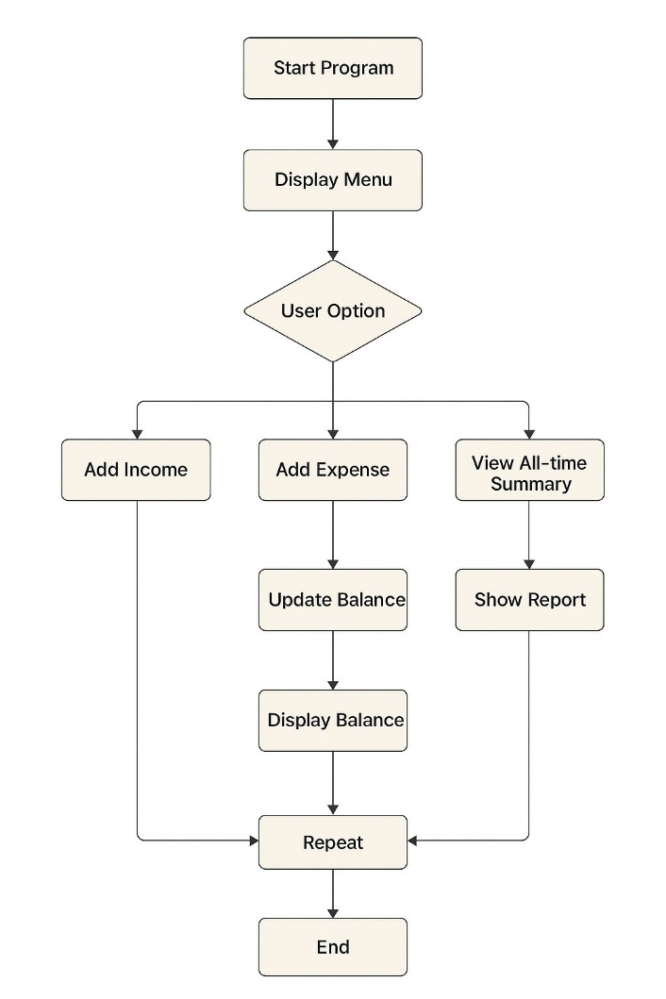

ASSUMPTIONS
The Personal Finance Tracker project is built and functions based on a set of key assumptions that ensure stable performance and accurate data management. It is expected that users will enter valid numeric values for all transaction amounts and follow the DD-MM-YYYY date format when recording income or expenses. The application runs in an environment that supports C++17, including standard libraries and file-handling capabilities.
All transaction records are saved in a local text file named finance_data.txt. It is assumed that this file remains accessible, free from corruption, and within manageable size limits. Users are expected to operate the system via the command-line interface (CLI), use clear and relevant categories with optional descriptions, and correctly navigate the menu to ensure that data is saved before exiting the application.
The system also relies on the assumption that the computer’s date and time settings are accurate, as they are used for automatic date assignment. The program is intended for single-user operation, with all information stored locally to maintain privacy and enable offline use. Users are advised not to edit the data file manually, as this may cause errors or inconsistencies.
These assumptions define the operational boundaries within which the application delivers reliable performance, data integrity, and user-friendly functionality.

IMPLEMENTATION

The implementation stage of the Personal Finance Tracker project involved converting the planned system architecture into functional C++ code. This phase emphasized modularity, data accuracy, and code reusability by applying Object-Oriented Programming (OOP) principles. The program operates as a console-based application, allowing users to record, view, and analyze their financial activities effectively.

1. Data Input
All information used by the system is provided directly by the user through the command-line interface (CLI). Each transaction entry includes the following details:
- Amount: A positive numeric value specified by the user.
- Category: A user-defined label such as Salary, Food, or Travel.
- Date: The transaction date in DD-MM-YYYY format; if not specified, the system automatically assigns the current date.
- Description: Optional notes or details about the transaction.
Before storing, the input values are validated to ensure accuracy and data integrity.

2. Processing Workflow
- Input Verification: Checks that the transaction amount is positive and the date follows the correct format.
- Object Instantiation: Generates a corresponding Transaction object—either Income or Expense—through the use of polymorphism.
- Balance Update: The Account class updates the total balance using the apply() method.
- Data Storage: Transaction records are saved in the file finance_data.txt in CSV format for persistent storage.
- Report Generation: The ReportGenerator class analyzes the stored data to produce monthly and overall summaries, grouped by category, helping users track their financial performance over time.

DIAGRAM
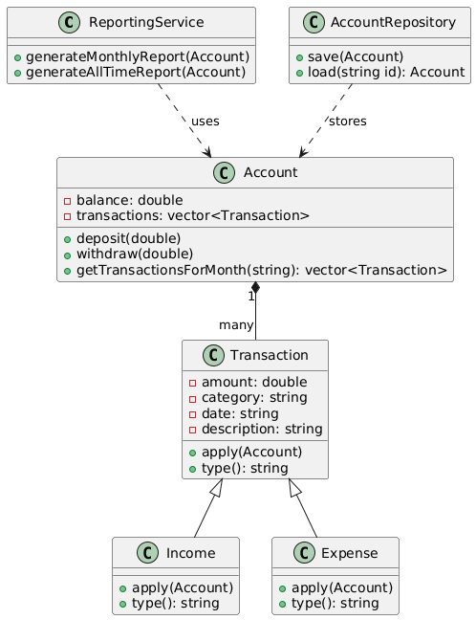

TABLES AND DATA REPRESENTATION
Type | Amount (Rs) | Category | Date | Description
Income | 5000.00 | Salary | 01-11-2025 | November Salary
Expense | 1200.00 | Food | 02-11-2025 | Lunch and groceries
Expense | 800.00 | Transport | 03-11-2025 | Office commute
The system reads these entries to compute total income, total expenses, and net savings dynamically.

SOLUTION DESIGN

parts, each with its The solution design of the Personal Finance Tracker is based on Object-Oriented Programming (OOP). This means the system is built using small parts (called classes and objects) that make it easy to update, reuse, and expand in the future. The design starts by looking at the main tasks — like managing transactions, creating reports, and saving data in files — and then divides them into smaller own clear job.

PRESENTATION LAYER (CLI)
This layer is the face of the application. It is the only part the user interacts with directly. In this project, it is a Command-Line Interface (CLI).
Its main responsibilities are to:
- Display the main menu and other prompts (for example, "1. Add Income", "Enter amount:").
- Capture all keyboard input from the user.
- Send the user's data, such as the details of a new transaction, to the Business Logic Layer for processing.
- Receive final, formatted data, like a report, from the Business Logic Layer and show it on the screen.
It does not perform any calculations or file operations.

BUSINESS LOGIC LAYER
This is the brain of the application. It contains all the main C++ classes, such as Account, Transaction, Income, Expense, and Report Generator. It enforces all the financial rules.
Its key responsibilities are to:
Act on requests from the Presentation Layer, such as creating a new expense.
Use the OOP classes to perform calculations, like adding to or subtracting from the balance in the Account class.
Manage the list of transaction objects in memory.
Tell the Report Generator to analyse the data and create a report.
Coordinate with the Data Layer, indicating when to save or load transaction data.

DATA LAYER (PERSISTENCE)
This layer is the "memory" of the project. Its only job is to manage permanent data storage, so it isn't lost when the application closes.
Its specific responsibilities are to:
Execute the saveToFile() logic, which writes the current list of transactions from the Account class into the finance_data.txt file.
Execute the loadFromFile() logic, which reads data from finance_data.txt and fills the Account class's transaction list when the program starts.
This layer keeps all file-handling operations separate, making the project cleaner and easier to maintain.

CHALLENGES & OPPORTUNITIES

CHALLENGES
During the development of the Personal Finance Tracker, several technical challenges arose and were effectively tackled:
- Data Validation:
To ensure that users input correct amounts and dates (DD-MM-YYYY), we implemented proper validation and exception handling.
- File Handling:
Managing data storage through text files without corruption or duplication needed careful use of file streams and organized formatting.
- Applying OOP Concepts:
Designing the system with abstraction, encapsulation, inheritance, and polymorphism while keeping it simple and readable was a major design challenge.
- Console Interface:
Presenting data clearly in a text-based environment without a graphical interface needed careful consideration of layout and formatting.

OPPORTUNITIES
The project offers several chances for improvement and future growth:
- Database Integration:
Replacing file storage with a relational database like MySQL or SQLite will provide better scalability.
- Graphical User Interface (GUI):
Adding a GUI with Qt will improve usability and visual clarity.
- Data Visualization:
Introducing charts and graphs will make financial insights more interactive and visually engaging.
- Cloud Backup:
Implementing optional cloud synchronization will allow for secure access across multiple devices.

REFLECTIONS ON THE PROJECT

The development of the Personal Finance Tracker project gave a great chance to use Object-Oriented Programming (OOP) concepts in a real-world setting. Designing and implementing the system helped deepen the understanding of abstraction, encapsulation, inheritance, and polymorphism. Each concept was crucial in making the code modular, reusable, and easy to maintain.

Working on this project also showed the importance of structured planning and design before starting to code. Turning requirements into clear classes and relationships illustrated how software engineering principles support effective problem-solving. Implementing file handling for data storage and creating monthly reports improved practical skills in data management and validation.

The project’s simplicity as a console-based application made it easier to concentrate on core logic and system design while still providing significant learning experiences in managing transactions and generating reports. It also pointed out possible areas for improvement, such as integrating a database and creating graphical interfaces, giving a clear path for future development.

In summary, this project strengthened both technical skills and analytical thinking, connecting theoretical programming knowledge with practical software development.

RECOMMENDATIONS

Based on the development and analysis of the Personal Finance Tracker project, several recommendations can be made to enhance its performance, usability, and long-term applicability.
- Integration with Databases:
The current system relies on text file storage, which is suitable for basic use but limits scalability. Integrating a database system such as MySQL or SQLite would enable efficient data storage, faster access, and support for multiple users.
- Graphical User Interface (GUI):
Implementing a GUI using frameworks such as Qt or JavaFX would make the application more user-friendly and visually appealing, improving overall user engagement.
- Advanced Reporting and Analytics:
Including graphical charts, spending trends, and savings insights would allow users to better visualize their financial activities and make informed decisions.
- Cloud Synchronization:
Providing an option for cloud backup or online synchronization could enhance data security and accessibility across devices.
- Security Features:
Adding basic authentication and encryption can help protect user data and ensure privacy.
Implementing these improvements would transform the current version into a more comprehensive and scalable personal finance management solution, suitable for both educational and practical use.

CONCLUSION

The Personal Finance Tracker project demonstrates the practical application of Object-Oriented Programming (OOP) concepts to address real-life challenges in managing personal finances. Through systematic design and structured implementation, the project successfully achieves its objective of enabling users to efficiently record, track, and analyze their financial transactions in an organized manner.
The system incorporates essential functionalities such as income and expense tracking, data storage in files, and generation of monthly and overall financial reports. Its modular architecture, built upon the principles of encapsulation, inheritance, and polymorphism, provides flexibility, clarity, and ease of future maintenance. Additionally, the project emphasizes the importance of accurate data handling, input validation, and clear report presentation within a simple console-based interface.
From a learning perspective, the project enhanced understanding of object-oriented design, file management, and real-time data operations in C++. It also highlighted the challenge of maintaining a balance between simplicity and functionality in software design.
In conclusion, this project illustrates how OOP methodologies can be effectively used to create a functional, educational, and maintainable software solution. It also establishes a strong base for potential enhancements, such as database connectivity, graphical user interface (GUI) implementation, and cloud-based storage, paving the way for a more scalable and dependable personal finance management system.

OUTPUT

Test Case :- 1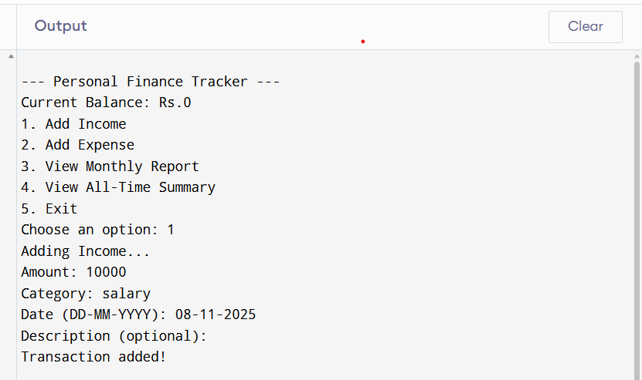
Test Case :- 2 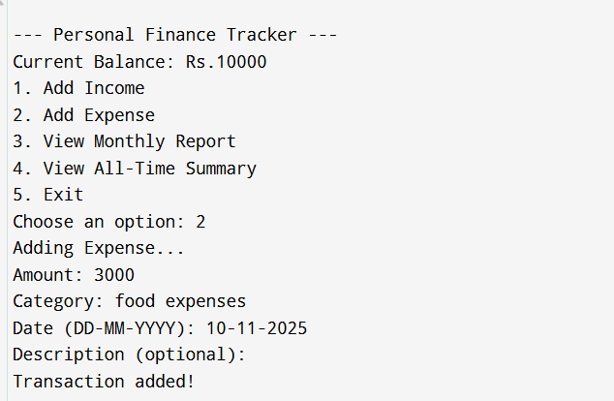

Test Case :- 3
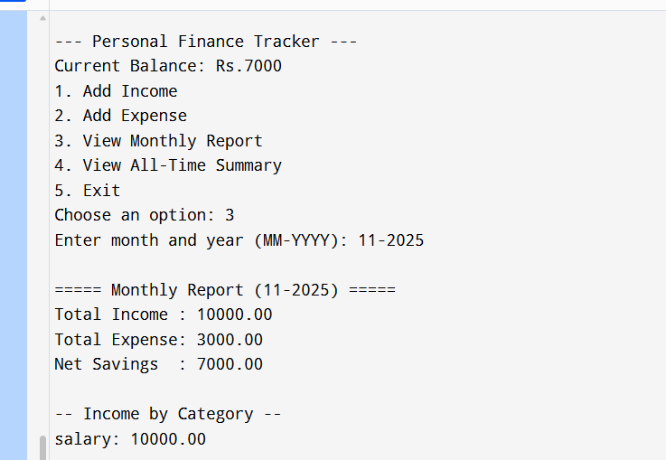
Test Case :- 4
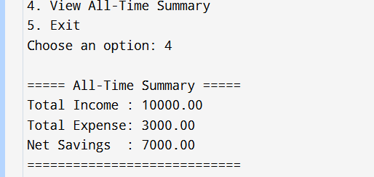

LINK TO CODE AND EXECUTABLE FILE

The complete source code and executable files for the Personal Finance Tracker (OOP in C++) project are provided for verification and execution purposes.
- Source Code File:
finance_tracker.cpp
Contains the full C++ implementation of the Personal Finance Tracker, including all classes, methods, and functionalities covering OOP principles such as abstraction, encapsulation, inheritance, and polymorphism.
- Executable File:
finance_tracker.exe
This is the compiled version of the C++ program, ready for direct execution on Windows systems with a compatible environment.
- Supporting Files:
  - finance_data.txt → Used for storing all transaction records persistently.
  - README.md → Contains setup instructions, features, and usage guide.
- Code Repository Link:
The complete project (source code, executable, documentation, and report) is available at the following location:
[GitHub Link Here]

RESEARCH QUESTIONS AND RESPONSES

During the development of the Personal Finance Tracker project, several research-oriented questions were identified and addressed to ensure that the system met both technical and functional expectations. These questions guided the design, implementation, and evaluation phases of the project.

1. How can Object-Oriented Programming (OOP) concepts improve code structure and maintainability?
By applying OOP principles such as encapsulation, inheritance, and polymorphism, the code was modularized into distinct classes (Transaction, Account, Income, Expense, and Report Generator). This reduced redundancy and improved scalability and readability.

2. What is the most efficient method to store user data without a database?
After evaluating multiple approaches, a file-based storage system using structured text (CSV format) was selected for simplicity, persistence, and offline accessibility.

3. How can the system ensure data accuracy and reliability?
Input validation checks for positive transaction amounts and correct date formats were implemented to prevent user errors and data inconsistencies.

4. What are the potential areas for enhancement?
Future improvements include integrating a database for scalability, implementing a GUI, and adding data visualization tools for analytical insights.

REFERENCES

1. Balagurusamy, E. (2019). Object-Oriented Programming with C++ (8th Edition). McGraw Hill Education.
— Provided fundamental understanding of C++ programming and object-oriented principles used in the project design.

2. Herbert Schildt. (2022). C++: The Complete Reference (5th Edition). McGraw Hill.
— Served as a reference for implementing class hierarchies, file handling, and input/output operations.

3. Bjarne Stroustrup. (2013). The C++ Programming Language (4th Edition). Addison-Wesley.
— Offered deep insights into modern C++ design patterns and programming best practices.

4. GeeksforGeeks. C++ File Handling and OOP Concepts. Retrieved from
— Consulted for examples and explanations related to file handling and OOP implementation in C++.

5.TutorialsPoint. Object-Oriented Programming in C++. Retrieved from

